**Unit III: IMAGE RESTORATION AND RECONSTRUCTION**

Image restoration and reconstruction are two important processes in the field of digital image processing. They both deal with improving the quality and clarity of images but involve different techniques and objectives. Let's explore each of them:

**Image Restoration:**

Image restoration aims to improve the quality of an image that has been degraded due to various factors such as blurring, noise, compression artifacts, or other forms of distortion. The primary goal of image restoration is to reverse or minimize the effects of these degradations and obtain a clearer and more visually pleasing version of the original image.

Common techniques used in image restoration include:

**a. Image Deblurring**: This process aims to remove blurriness caused by motion, defocus, or other reasons to enhance the sharpness and clarity of the image.

**b. Image Denoising:** Noise in an image can be random variations in pixel values, which reduce image quality. Denoising techniques aim to reduce or eliminate this noise while preserving important image features.

**c. Image Inpainting:** Inpainting methods are used to fill in missing or damaged regions in an image using surrounding information to make the image complete.

**d. Super-resolution:** Super-resolution techniques are used to enhance the resolution of an image, effectively increasing the level of detail beyond the original image resolution.

**Image Reconstruction:**

Image reconstruction involves the process of creating a new image from incomplete or partial information. This often occurs in the context of medical imaging (e.g., CT scans, MRI) or other applications where only limited data is available to form a complete image.

Common techniques used in image reconstruction include:

**a. Tomographic Reconstruction:** This technique is used in medical imaging and involves the reconstruction of 3D images from a series of 2D X-ray projections or slices.

**b. Compressed Sensing:** Compressed sensing is a method that allows reconstructing an image from significantly fewer data points than traditionally required, based on the assumption that the image has a sparse representation in some domain.

**c. Interpolation:** Interpolation methods are used to estimate pixel values at unknown positions based on neighboring pixels. This is often used in image resizing and zooming operations.

**d. Image Mosaicing:** Image mosaicing involves stitching multiple overlapping images into a single large image, commonly used in panoramic photography.

**A model of the image degradation and Restoration process**

1. **Image Degradation:**

The image degradation process involves introducing various factors that reduce the quality of the original image. These factors can include:

**a. Blurring:** Simulate blurring effects that occur due to camera shake, defocus, or other motion during image capture.

**b. Noise:** Add random variations to pixel values to simulate noise introduced during image acquisition or transmission.

**c. Compression:** Apply lossy compression to reduce image data size, leading to the loss of some image details.

**d. Other Distortions:** Simulate other types of distortions that can occur during image acquisition or processing.

**Image Degradation Model:**

In the image degradation process, we create a model that describes how each degradation factor affects the original image. For example:

**a. Blurring Model:** Specify the type and amount of blurring (e.g., Gaussian blur, motion blur) and its parameters (e.g., blur kernel size, direction, and strength).

**b. Noise Model:** Define the type and level of noise (e.g., Gaussian noise, salt-and-pepper noise) and its characteristics (e.g., mean and variance).

**c. Compression Model:** Specify the compression algorithm and the compression ratio used to reduce the image size.

**d. Other Distortion Models:** Define appropriate models for other types of distortions being considered.

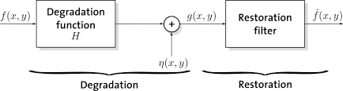

1. **Image Restoration:**

The image restoration process aims to reverse or reduce the effects of degradation on the degraded image to obtain an improved version closer to the original image. This process typically involves applying various restoration techniques:

**a. Deblurring:** Use deblurring algorithms to estimate and remove the blur from the degraded image.

**b. Denoising:** Utilize denoising algorithms to estimate the original pixel values by reducing the noise present in the degraded image.

**c. Inpainting:** Apply inpainting methods to fill in missing or damaged regions in the image using neighboring information.

**d. Super-resolution:** Use super-resolution techniques to enhance the resolution and recover fine details in the image.

* **Image Restoration Model:** Similar to the degradation model, the image restoration process requires a model that describes how to undo each degradation effect. This involves defining appropriate restoration algorithms and parameters for each restoration technique used.
* **Evaluation:** Finally, the restored image is evaluated to assess the effectiveness of the restoration process. This evaluation can be done qualitatively by visual inspection or quantitatively using metrics like Peak Signal-to-Noise Ratio (PSNR), Structural Similarity Index (SSIM), or other relevant quality measures.

**Noise models**

In image processing and computer vision, noise models are used to simulate the random variations or errors that can occur during image acquisition, transmission, or processing. Understanding and modeling noise is essential for developing effective denoising algorithms and for evaluating the performance of image processing techniques. Here are some common noise models used in the context of digital images:

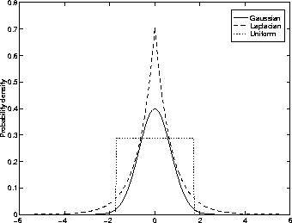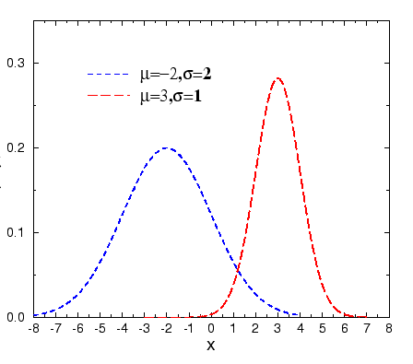

1. **Gaussian Noise:** Gaussian noise is one of the most common types of noise encountered in digital images. It is characterized by pixel value variations following a Gaussian or normal distribution. This type of noise can be caused by various factors, including electronic sensor fluctuations, quantization errors, or even environmental factors during image capture.
2. **Salt-and-Pepper Noise:** Salt-and-pepper noise, also known as impulse noise, introduces random occurrences of very bright or very dark pixels in an image. This noise model simulates the effect of occasional random pixel corruption during image acquisition or transmission. The noisy pixels are similar to grains of salt or pepper sprinkled throughout the image.
3. **Poisson Noise:** Poisson noise is often encountered in images that have low light levels or are obtained using photon-sensitive sensors like X-ray imaging or certain types of microscopy. It follows the Poisson distribution and is characterized by variations in pixel intensities that depend on the average intensity level.
4. **Speckle Noise:** Speckle noise is commonly observed in radar, ultrasound, and synthetic aperture radar (SAR) images. It appears as a granular pattern caused by constructive and destructive interference of signals. Speckle noise is multiplicative in nature and is often modeled using a multiplicative noise model.
5. **Quantization Noise:** Quantization noise occurs when continuous-valued signals, like the intensities of an image, are represented in a discrete form with a limited number of bits. This process of discretization introduces rounding errors, leading to quantization noise.
6. **Gaussian Mixture Model (GMM) Noise:** GMM noise is a more advanced noise model that represents the image noise as a mixture of multiple Gaussian distributions with different variance and mean values. It is a more realistic model for certain types of noise, which cannot be accurately captured using a single Gaussian distribution.

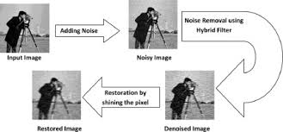

**restoration in the presence of noise only-Spatial Filtering**

Restoration of images in the presence of noise can be achieved using spatial filtering techniques. Spatial filtering is a common method used for image processing tasks like denoising, sharpening, and edge detection. In the context of noise reduction, spatial filtering aims to remove or reduce the noise while preserving the important image features. One of the most widely used spatial filtering techniques for denoising is the application of linear filters, such as the mean filter and the Gaussian filter. Let's explore these filters:

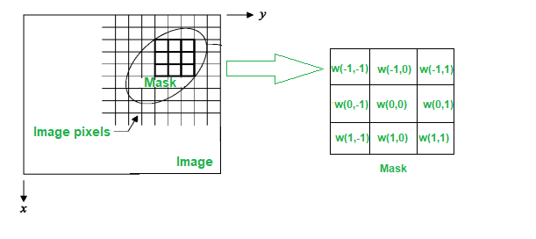

***Mean Filter:*** The mean filter is a simple and effective linear filter used for denoising images. It operates by replacing the pixel value at a given location with the average value of its neighboring pixels. The size of the neighborhood (kernel) used for averaging is an important parameter in this filter.

The steps involved in applying a mean filter for denoising are as follows:

* Define a kernel or window of a certain size centered at each pixel in the image.
* Compute the mean (average) of the pixel values within the kernel.
* Replace the pixel value at the center of the kernel with the computed mean.

The mean filter works well for reducing Gaussian noise and other types of random noise, but it may not be very effective for removing salt-and-pepper noise.

***Gaussian Filter:*** The Gaussian filter is another popular linear filter used for denoising. It is based on a Gaussian distribution and is more effective than the mean filter for removing Gaussian noise.

The steps involved in applying a Gaussian filter for denoising are as follows:

* Define a Gaussian kernel with a specified standard deviation (sigma) and size.
* Convolve the Gaussian kernel with each pixel in the image.
* Replace the pixel value at the center with the weighted sum of the neighboring pixels, where the weights are determined by the Gaussian distribution.

The Gaussian filter smooths the image and reduces noise effectively, especially when the noise follows a Gaussian distribution.

**It's** worth noting that while spatial filtering can be effective for simple noise reduction, it may also blur important image details. More advanced denoising techniques, such as wavelet denoising and non-local means denoising, have been developed to address this issue and provide better noise reduction while preserving image features.

**Periodic Noise Reduction by frequency domain filtering**

Periodic noise is a type of repetitive and predictable pattern that can appear in images due to various factors such as interference during image acquisition or transmission. It manifests as regular variations in pixel values across the image. To reduce or eliminate periodic noise, frequency domain filtering techniques are commonly used. These methods involve transforming the image from the spatial domain to the frequency domain using the Fourier transform, applying appropriate filtering, and then transforming it back to the spatial domain.

The steps for periodic noise reduction by frequency domain filtering are as follows:

1. **Fourier Transform:** Perform the Fourier transform of the noisy image to convert it from the spatial domain to the frequency domain. The Fourier transform represents the image in terms of its frequency components (amplitude and phase) instead of pixel intensities.
2. **Visualizing the Spectrum:** The frequency domain representation of the image will contain the periodic noise as peaks in the frequency spectrum. By visualizing the spectrum, you can identify the frequencies corresponding to the noise.
3. **Filtering in Frequency Domain**: Design a frequency domain filter that removes or attenuates the noise frequencies while preserving the important image content. There are different types of filters that can be used, such as ideal filters, Butterworth filters, and Gaussian filters.

* **Ideal Filter:** An ideal filter is a binary filter that removes frequencies above a certain cutoff and retains frequencies below the cutoff. It can effectively eliminate noise but may cause blurring of image details.
* **Butterworth Filter:** The Butterworth filter is a type of low-pass filter that smoothly attenuates frequencies above a specified cutoff. It offers a balance between noise reduction and image sharpness.
* **Gaussian Filter:** The Gaussian filter reduces high-frequency noise while preserving the low-frequency components. It provides smoothing without introducing sharp artifacts.

1. **Applying the Filter:** Multiply the frequency domain representation of the noisy image with the frequency domain filter to apply the filtering operation.
2. **Inverse Fourier Transform:** Perform the inverse Fourier transform to convert the filtered frequency domain image back to the spatial domain.
3. **Optional Post-Processing:** Post-processing may be applied to the restored image, such as clipping negative values or rescaling the pixel intensities to ensure they remain within the valid range.

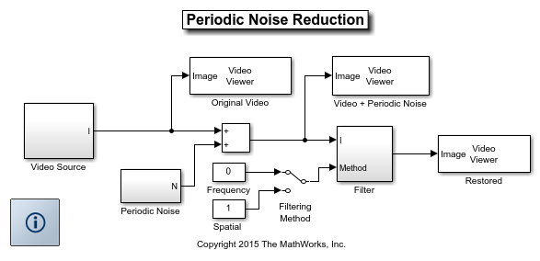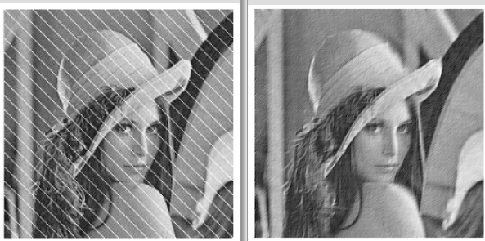

It's essential to select appropriate parameters for the filter, such as the cutoff frequency and filter order (in the case of Butterworth filters). The effectiveness of frequency domain filtering for periodic noise reduction depends on the accuracy of identifying the noise frequencies and the proper choice of the filtering method.

**Minimum mean square error (Wiener) filtering**

Minimum Mean Square Error (MMSE) filtering, also known as Wiener filtering or Wiener deconvolution, is a powerful technique used in image and signal processing for image restoration and denoising. It is an extension of the inverse filtering method and addresses some of its limitations, such as sensitivity to noise and instability.

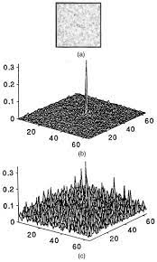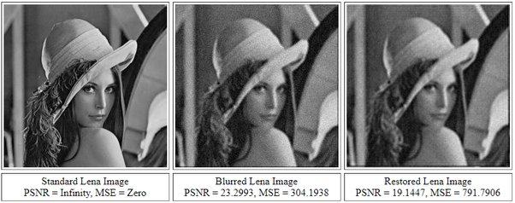

**The** Wiener filter estimates the original clean image from its degraded version by minimizing the mean square error between the estimated image and the true clean image. It is based on statistical principles and is particularly useful when the degradation process and noise characteristics are known or can be estimated.

The steps involved in Wiener filtering for image restoration are as follows:

**Degradation Model:** As with inverse filtering, the degradation process is represented using a point spread function (PSF) or blurring kernel. Additionally, the Wiener filter also accounts for the presence of additive noise in the degraded image.

**Frequency Domain Conversion:** The degraded image and the PSF are transformed into the frequency domain using the Fourier transform.

**Wiener Filter Estimation:** The Wiener filter is designed based on the estimated power spectra of the clean image and the noise. The Wiener filter is calculated as follows:

* Ĥ(f) = G(f) * conj(P(f)) / (|P(f)|^2 + K),

where:

* Ĥ(f) is the frequency domain representation of the Wiener filter,
* G(f) is the frequency domain representation of the degraded image,
* P(f) is the frequency domain representation of the PSF (degradation function),
* conj(P(f)) is the complex conjugate of P(f),
* |P(f)|^2 is the squared magnitude of P(f), and
* K is the Wiener filter regularization parameter.

The regularization parameter K is introduced to stabilize the Wiener filter and control the trade-off between noise amplification and detail preservation. Its value is chosen based on the characteristics of the noise and the restoration requirements.

**Filtering in Frequency Domain:** The degraded image is multiplied with the Wiener filter in the frequency domain.

**Inverse Fourier Transform:** The filtered result in the frequency domain is transformed back to the spatial domain using the inverse Fourier transform, producing the estimated clean image.

**The** Wiener filter provides an optimal trade-off between noise reduction and image sharpening, considering the statistical properties of the degradation and noise. It is effective when the degradation and noise characteristics are well understood or can be estimated accurately.

**constrained least squares filtering**

Constrained least squares filtering is a technique used for image restoration and denoising, where the restoration process is formulated as a constrained optimization problem. It aims to find the best estimate of the clean image by minimizing a cost function that includes a data-fidelity term (related to the observed degraded image) and additional constraints on the estimated image.

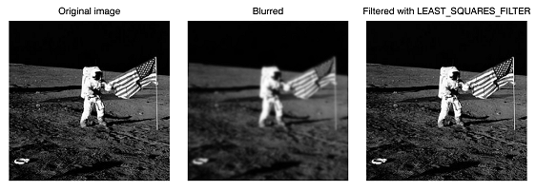

In the context of image restoration, the degraded image can be represented as:

* G = F * H + N,

where:

* G is the observed degraded image,
* F is the true clean image (unknown and to be estimated),
* H is the point spread function (PSF) or blurring kernel representing the degradation process,
* N is the noise in the observed image.

The goal of constrained least squares filtering is to estimate the clean image F from the observed degraded image G, considering the degradation model and additional constraints.

The constrained least squares filtering approach involves the following steps:

**Cost Function:**

The cost function to be minimized is typically based on the least squares error between the observed image G and the estimated image F convolved with the degradation kernel H. It can be formulated as:

* J(F) = ||G - F * H||^2.

The cost function quantifies the difference between the observed degraded image and the estimate of the clean image, taking into account the degradation process.

**Additional Constraints:**

Constrained least squares filtering incorporates additional constraints on the estimated image F to ensure the restoration produces plausible results. These constraints are problem-specific and can be based on prior knowledge about the image content or properties.

Common constraints include:

* **Positivity Constraint**: Ensuring that the estimated pixel values of the clean image are non-negative.
* **Total Variation (TV) Regularization:** Encouraging the estimated image to have smooth regions by penalizing sharp intensity changes across neighboring pixels.
* **Sparsity Constraint:** Encouraging the estimated image to have many zero or near-zero values in some domain (e.g., wavelet or transform domain), promoting sparse representations.

**Optimization:** The constrained least squares filtering problem is solved by optimizing the cost function with respect to the unknown clean image F while respecting the additional constraints.

This optimization process can be carried out using various numerical techniques such as gradient-based methods, iterative algorithms, or convex optimization methods.